Department of Statistics

The Wharton School

University of Pennsylvania

STAT 603 August 2005

Module 3
Sources of Variation

Statistics and Variation

In many ways, Statistics can be seen as the study of variation in data.

Basically, we would like to “explain” the variation in data. Why? If we can identify what is causing the data to vary, we might be able to control this variation to our benefit.

At a minimum, we would like to understand why our data vary. The reasons for variation are what we’ll call the “sources of variation.”

Back to the Forbes Compensation Data (BBS, p.45)

A question of interest: Are executives in some industries more highly paid than those in others?

We’ll use FrbSubt.jmp which restricts the data to a subset of 10 industry categories

Let’s first obtain summaries of the two variables WideIndustry and Log10TotalComp

Goal is to compare compensation among industries.

The summaries of these two reveal the variation of each variable.

Should we use the “raw” compensation, or use compensation on the log scale?

What about the relationship between compensation and industry category?

For example, are executives in some industries consistently more highly paid that those in other industries?

Plot Linking
To get some sense of the relationship between them, we can highlight industries such as Financial or Utility. Plot linking in JMP highlights the associated values of Log10TotalComp.
Does it look like Financial or Utility executives are paid differently? Are the differences small, happening just for one or two, or more general?
Comparison Boxplots
Another useful approach for comparison is to look at comparison boxplots.
Each boxplot summarizes compensation within an industry. The plots are shown parallel to each other on the same scale. What can we say about the executive compensation differences across these industries? (BBS, p.48)

Predicting Airline Passenger Demand (BBS, p.50)

A question of interest: How might one go about predicting future demand in a growth industry?

The file IntlAir.jmp contains monthly passenger data from 1949 to 1960, a period of rapid growth.

To anticipate demand, let’s use this data to predict the number of passengers in January 1961.

Since this is time series data, we’ll start by looking at a time series plot just as we did with the GM data in Module 2.

Does the data look like a random sample, or does it show the meandering appearance of dependence?

How would you describe the variation in the passenger level over time? What explains the changes in this series?
Here is the summary of the distribution of Passengers

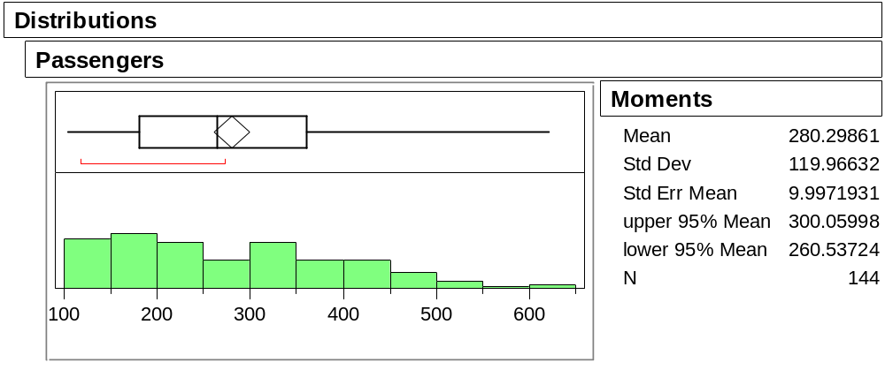

Should we use the mean of about 280,000 per month to predict January 1961?

Why not?

Working with Relative Changes

Let’s instead look at the successive monthly relative changes, just as we did with the time series that gave prices of GM stock data,
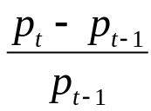

where p_{t} is the value of Passengers in month t.

Here is the corresponding time series plot (BBS, p.52)

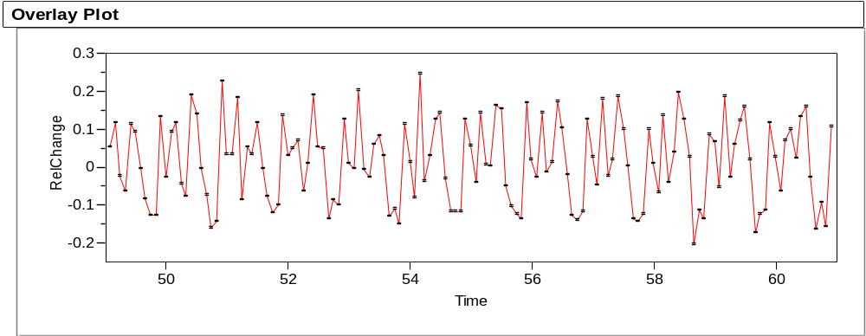
along with the summary of the distribution of the relative changes.

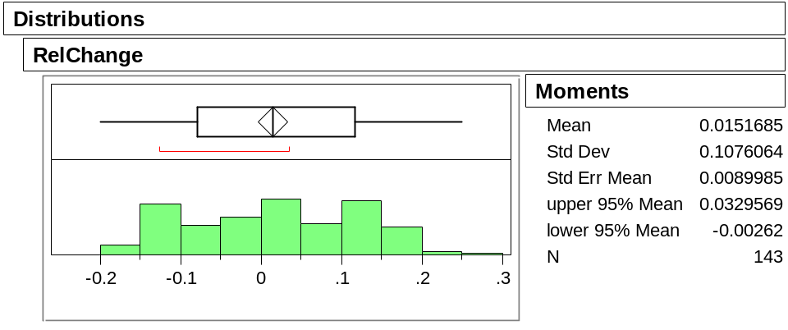

What happened to the upward trend?

At first glance, it appears that the mean relative change, about 1.5%, is about the same throughout.

Thus, we might consider predicting the January, 1961 value by 432,000 x 1.015 ≈ 438,000, where 432 is the December, 1960 value. This certainly is better than the mean of 280,000.
We can do even better! Let’s mark the September values (BBS p.52-53)

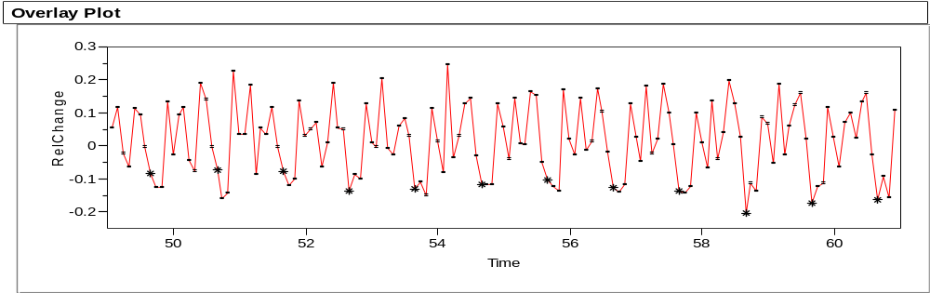

and then mark the December values

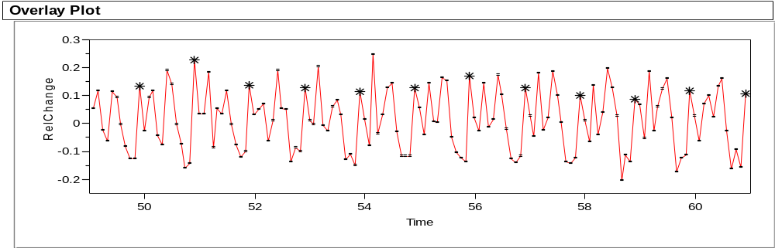

What’s going on?
Seasonality
A more complete picture of this month-to-month variation, called seasonality, is given by comparison boxplots organized by month (BBS, p.53)

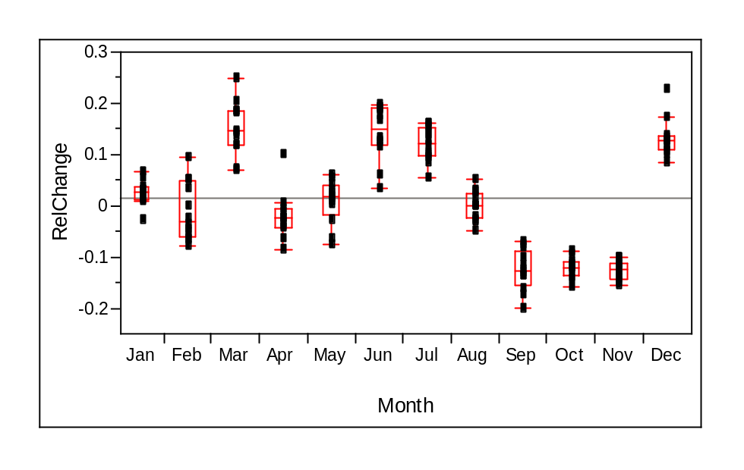

Note that months 3, 6, 7, 12 tend to be systematically high and months 9, 10, 11 are systematically low. This seasonal effect drives the replicating pattern that we observed in the original time series plot.

The mean change is January is about 2.6% leading to a more appealing estimate of demand for the next January, 432,000 x 1.026 ≈ 443,000.
Monitoring an Automotive Manufacturing Process (BBS, p.55)

A question of interest: Is the process currently used to manufacture motor shafts consistently producing satisfactory components?

To study the motor shaft production process at an engine-building plant, 5 shafts were sampled and measured each weekday for 4 weeks.

Standards required for engine assembly require the diameter to fall between 810 and 820 thousands of an inch. These are called acceptance limits.

We would like to know if the process is

In Control – behaves like a sequence of independent draws from one population

Capable – output falls within acceptance limits

Notice that a process can be in control, but not capable. Similarly, a process can be capable, but not in control.

The data for these 100 shafts is in ShaftDia.jmp; a larger set of 400 is in ShaftXtr.jmp
A times series plot of the 100 shaft diameters (with a center line at the mean) reveals no systematic trend, thereby suggesting that the process is in control

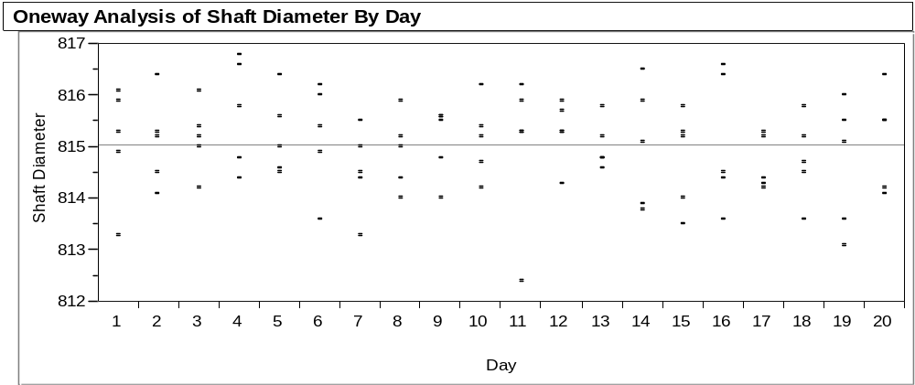

Here’s the summary of the distribution of Shaft Diameter (BBS, p.56)

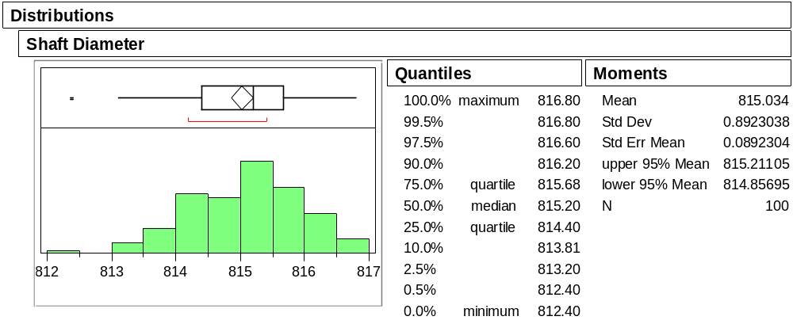

All the measured shafts fall well within the acceptance limits 810 and 820.

The process is capable.

Going Further: What can we learn about the process?

A broader goal is not simply to check these 100 shafts, but rather to make statements about future shafts produced by the underlying manufacturing process.
For example, suppose we would like to estimate the probability that the diameter of some future shaft falls outside the acceptance interval (810, 820).
To make such inferences, we need to assume some shape for the population. We can start by using the normal quantile plot to see if it is reasonable to treat the population (i.e., the total process output) as normal (BBS, p.57)

Does the following normal quantile plot lend support to such an assumption?

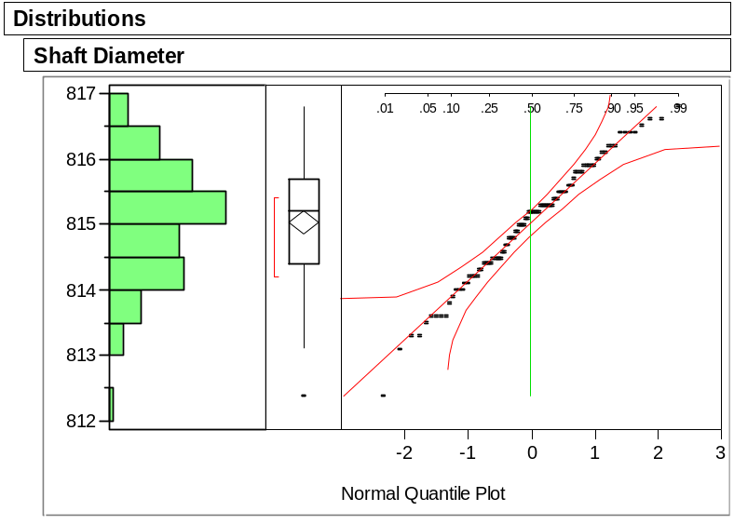
Suppose we are willing to assume that the process remains in control and that the population is normal with mean 815 and standard deviation .89, (where did these numbers come from? See BBS, p.57)

Then the probability that a future shaft diameter will be outside the interval (810,820) is less than .000000005.

Here’s a more recognizable calculation…

Under our assumptions, what is the probability that a future shaft diameter will be outside the interval

(815 – 3(.89), 815 + 3(.89)) = (812.33, 817.67)?

This interval’s endpoints are called 3-sigma control limits and are often used to monitor such a process.

A popular strategy is to deem the process as out of control and needing some corrective action when a value falls outside these 3-sigma limits.

How often will such a strategy incorrectly deem the process to be out of control?
Some details of one relevant calculation are given in BBS, p.58-59.

To lower this probability, wider control limits could be used. What is the tradeoff of such a strategy?

CAREFUL!!! Do not confuse control limits with acceptance limits. They are not the same thing!!!

Take-Away Review

A key objective is to learn from data about the underlying sources of variation, such as

- Variation due to clustering or grouping.

- Variation determined by systematic effects over time.

- Variation due to chance

Plots and summary statistics help us understand variation.

Normality allows us to offer a probability for some future event, assuming that the future looks like the past.

Next Module

Probability and models for random variation.

Again use Analyze > Distribution. Note that because WideIndustry is a categorical variable (a column with text data that identify groups of observations), JMP automatically provides the summaries in terms of counts and proportions
The following plot is obtained using Analyze > Fit Y by X, selecting Log10TotalComp as Y and WideIndustry as X. To show the boxplots, right click on the title bar and select Boxplots under Display Options.
We’ll discuss more sophisticated checks for the presence of a systematic trend later in the course.
810 and 820 are more that 5.6 standard deviations from the mean.

